**Friday, 26 Jan 2018, 2-3PM, a semi-formal meeting at Chris’s place**

**Checking the progress with to do lists:**

Searching in the literature to see if any person found negative growth rates (no one came to negative answers, still seems to be a meaningful assumption)

The arterial pole asymmetry is modelled as a circumferential contraction (negative circumferential growth)

Visualise the rates with ellipsoids and circulate images or exfiles + cmgui files (Thursday)

Run some simulations for the next stages with DM BC on hpc2 or hpc6 if required (deferred to weekend, the ideal form of DM BC is not developed yet)

Finalise the results and try to find the continuity/harmony (Monday, final results of stage 10-11)

**Issues which are discussed:**

Among the answers of the ALPSO, 30-50% of the growth rates were in the borders, using SLSQP they are all resolved, and objective function is highly improved.

New results show a good continuity in 10-11 in terms of sheet rates, versus element numbers.

Growth rates are visualised using ellipsoids spatially.

DM BC needs to be applied in a way which prevents the rotation. Creating an extra element in the location of connection will help, as it brings enough constraint to the model which prevents rotation, and does not need to fix bottoms. (Model need to be fully fixed on its middle on this stage. We still need to improve DM BC for the later stages. Fully understanding other researchers’ BC is recommended)

Results of early simulation with another proposed BC (fixing a line as DM + fixing some nodes on top and bottom) shows that the mesh attempts to buckle.

**Plan for the next week:**

A1 poster needs to be prepared by the end of the next week for the ABI forum (I will plan to finish it by Thursday meeting time).

Checking the DM BC in Le Garrece‘s paper. (Looking if any of them have any other publications)

Inserting the extra element for the DM connection in the mesh of stage 11-12 (and probably 13?).

Running the simulation for the sub-stages in stages 11-12 on hpc.

==========

 To account for the mechanical constraints observed in biological samples, the poles of the cylinder were fixed in the cranio-caudal (z) axis. In addition, the dorsal mesocardium was simulated by constraints along two vertical lines dorsally, restricting displacement in the dorso-ventral (y) and cranio-caudal (z) axes. The breakdown of the dorsal mesocardium was simulated by a progressive release of this constraint, starting from the nodes at mid-length of the tube and progressing towards the poles:

**Computer simulations of heart looping integrating mechanical constraints and left-right asymmetries.**

(**A**) Timeline of the simulations, with the successive events reflecting experimental observations. (**B**) Simulation of heart shape changes in 3D with a Finite Element model of a straight tube, seen from left (top) and right (down) views. The arterial pole asymmetry is modelled as a circumferential contraction (negative circumferential growth) on the right side and an expansion (positive circumferential growth) on the left side, both in a gradient towards the mid-length of the tube. The asymmetry at the arterial pole is calibrated to generate a 25° rotation. Simultaneously, the inflation of the ventricular chambers and the breakdown of the dorsal mesocardium (black bars), from the mid-length of the tube, are initiated. Where the dorsal mesocardium is present, the tube is free to move only along the x direction (f(x)). Where it has broken down, the tube is free to move along all the three directions (f(x,y,z)). (**C**) The venous pole asymmetry is modelled as a difference (2.8-fold) in longitudinal growth between the right and the left side. At this stage, breakdown of the dorsal mesocardium has progressed towards the poles, and thus, the tube is free along half of its length. (**D**) 3D shape of the cardiac tube at the end of the simulation showing the typical helix of the looped heart tube. The right (RV) and left (LV) ventricles are in darker and lighter blue, respectively. (**E–H**) Comparison of biological and simulated shapes. (**E**) Ventral views of 3D reconstructions of the heart tube at E8.5g, when looping begins. On the right, the myocardial layer (yellow) is made transparent, revealing the tube axis (red), and the notochord behind (green). (**F**) Ventral view of a simulated heart tube at step 60. The axis of the tube is shown as a red line. (**G**) Ventral views of 3D reconstructions of the heart tube at E8.5i, when looping has progressed to a counter-clockwise helix (as seen from the arterial pole). (**H**) Ventral view of a simulated heart tube at step 90.

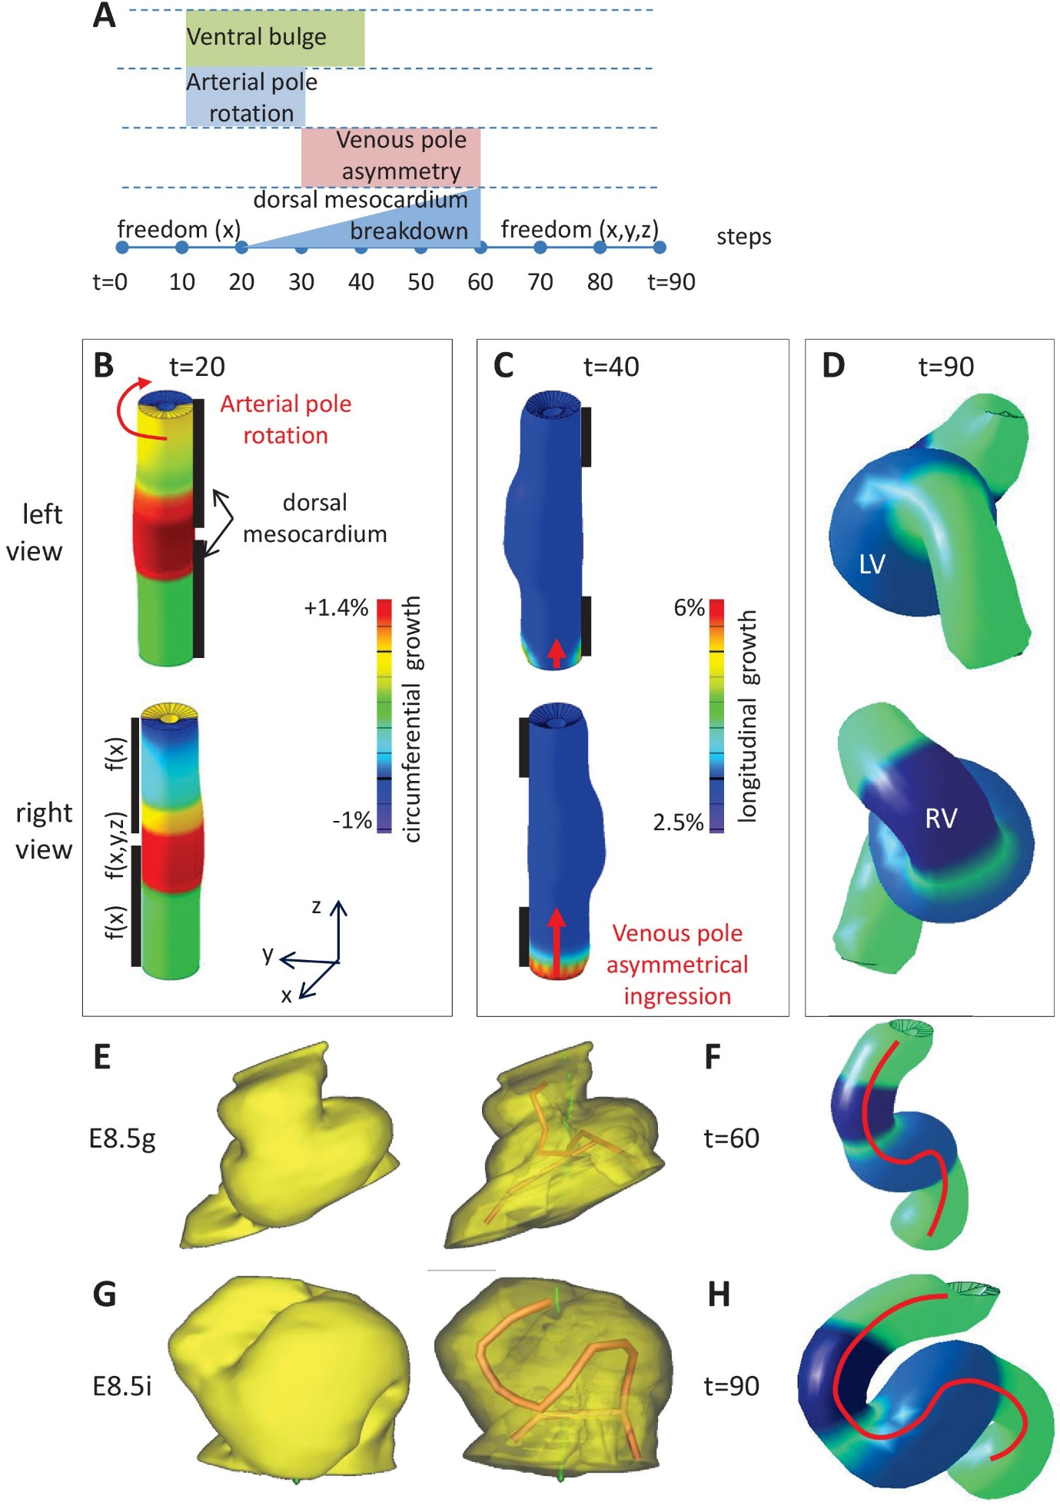

Shi:

Principal directions (**e**R, **e**θ, **e**Z) were defined for each element following anatomic features of the undeformed HT. **For boundary conditions, the cranial end of the outflow tract was fixed while all other boundaries were free**. Material properties for both MY and CJ were adopted from the cylinder model (see Eq. [(3)](https://www.ncbi.nlm.nih.gov/pmc/articles/PMC4056422/#FD3)). As an approximation, the outflow tract and the remnant omphalomesenteric veins were taken as passive, while the rest of the MY layer was assumed to undergo the same morphogenetic processes (contraction, growth, cell-shape change, etc.) as defined by the parameter values extrapolated in each region from those given by the cylinder model.

Studying bending in isolated hearts has several advantages over conducting experiments with whole embryos. Devoid of the complicating effects of torsion, isolated hearts are not affected by mechanical loads external to the HT and can be manipulated relatively easily for strain and stress measurements. However, it is important to note that the shape of the heart in ovo is affected by boundary conditions at the ends of the HT. On the other hand, as shown by Flynn et al. [[53](https://www.ncbi.nlm.nih.gov/pmc/articles/PMC4056422/#B53)], freeing one end of the looped heart in the embryo allows it to assume a bent configuration similar to that seen in isolated culture. This observation suggests that the intrinsic bending mechanism in ovo is the same as that in isolated hearts cultured in vivo.